
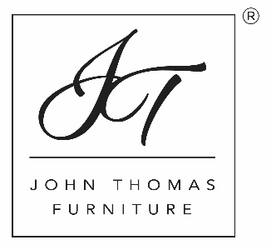

Margaritaville by John Thomas Furniture Advertising/Promotional Parameters

Approved Dealers must adhere to all rules and guidelines regarding the advertising and/or promotion of Margaritaville by John Thomas Furniture. Failure to comply with these guidelines could result in the termination of contracts and orders for the dealer.

- All advertising/promotions of the collection must mention John Thomas Furniture as the primary brand paired with Margaritaville Consumer Products, LLC. Advertising/Promotions may be co-branded in addition to John Thomas Furniture. See example below:
Example A (approved): Dealer ABC is proud to offer Margaritaville by John Thomas Furniture at all locations nationwide!
Example B (not approved): Dealer ABC is the proud home of Margaritaville products for your home!

- Margaritaville Consumer Products, LLC and John Thomas Furniture/Whitewood Industries reserves the right to object to/refuse third party co-branding. The cost and expense associated with this action is the sole responsibility of the third party, not Margaritaville Consumer Products, LLC or John Thomas Furniture/Whitewood Industries.
- All products sold from the collection are to private customers for their private use. No commercial purchases are approved.
- All depictions of the Official Margaritaville Artwork, and their copyrights, are owned by Margaritaville Consumer Brand, LLC. Absolutely no changes/modifications are allowed.
- All advertising/promotions of the collection shall not denigrate or cause the denigration of Margaritaville Consumer Products, LLC, Jimmy Buffet, John Thomas Furniture, Whitewood Industries, JP Home, and Custom Contract Furnishings.
- All product photography/video/media distributed by John Thomas Furniture are owned by John Thomas Furniture/Whitewood Industries and should not be altered in any way that changes the true likeness of the product.
- Discounts on products from the collection are up to and including twenty percent (20%) of the commercially reasonable wholesale price. Discounts more than twenty percent (20%) of the commercially reasonable wholesale price shall be subject to John Thomas Furniture’s prior written approval, on a commercially reasonable basis. Further, discounted sales shall not exceed twenty percent (20%) of the total Net Sales in any particular year.

